Java application, project 3 of 10

We are creating an application called “Teacher’s Sunrise Workout,” which will be coded with Java as its programming language in Eclipse and its Eclipse Window Builder for the design of the application.

We are expecting you to use as many of the four OOP concepts as you can.

You are also instructed to utilise at least 13 of the following 15 aspects below for the project to be marked as sufficiently complicated’.

1. Arrays
2. User-defined objects
3. Objects as data records
4. Simple selection (if-else)
5. Complex selection (nested if, if with multiple conditions, or switch)
6. Loops
7. Nested loops
8. User-defined methods
9. User-defined methods with parameters (the parameters have to be useful and used within the method body)
10. User-defined methods with appropriate return values (primitives or objects)
11. Sorting
12. Searching
13. File i/o
14. Use of additional libraries (such as utilities and graphical libraries not included in Appendix 2 Java Examination Tool Subsets)
15. Use of sentinels or flags

The information about the project is provided below; however, we do acknowledge your competence in coding and app development; hence, if you suggest any changes or want to make changes to the design to make it more organised and nicer, please consult and do it. A sun peeking out in the corner of the login page next to the name of the app is needed. FYI, the sketches are drawn in pencil; however, we need colour in the app, preferably something related to sunrise,yellow, or workout,blue.

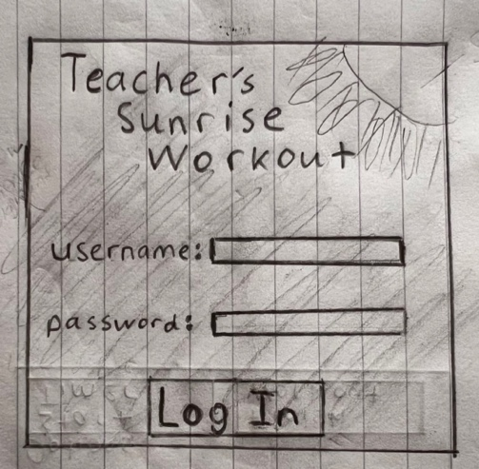First page: Log in page

Users can only access the application if the username and password they input are in the database.

But at first user need to register.

Add Register Page which will kinda look like login page

Second Page: Home page

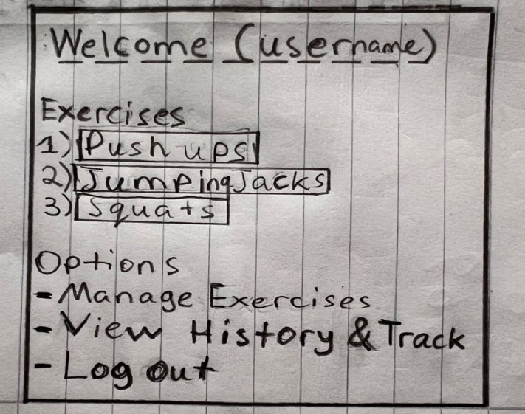

"Username" is the username according to what the user logged in with.

The numbering of exercises below "1) Push Ups,” "2) Jumping Jacks," and "3) Squats" are all buttons, and when pressed on, they will lead the user to the ""Exercise Name” Workout” page. The same applies to the option lists “Manage Exercises” and “View History & Track, where they are all buttons that lead to their own page. The Log Out button returns the user back to the log-in page.

Third page:” Manage your Exercises”

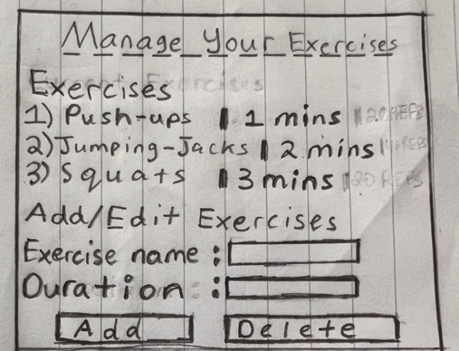

On this page, the “Exercises” and the list of exercises below will simply display the list of exercises and their duration set by the user; if the user just logged in and doesn’t have any exercises added, display below Exercises "Empty." Below, Add/Edit Exercises are just labels, and the user can input the name of the exercise and duration and press ADD to add it to "Exercises." Once the user presses ADD, it automatically saves the exercise, adds it to the exercises list on the third and second home pages, and directs the user back to the home page.

Fourth page: The page you display after an exercise button under “Exercises” is pressed.

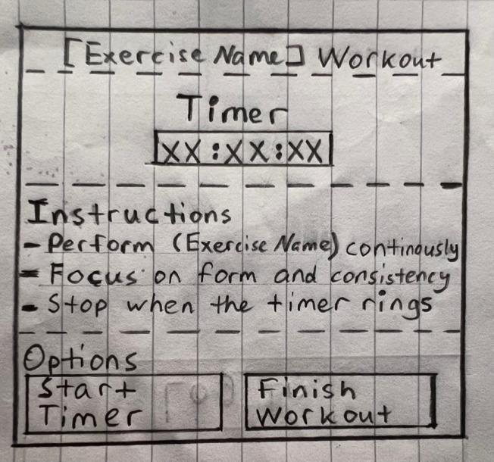

The “Start Timer” button will start the timer, and the timer will display the duration selected for the workout by the user on the third page, “Manage your exercises." Once the timer stops, just input a simple stock MP3 stopwatch sound. The “Finish Workout button will redirect the user back to the homepage.

Fifth Page: Track and View your Workout History

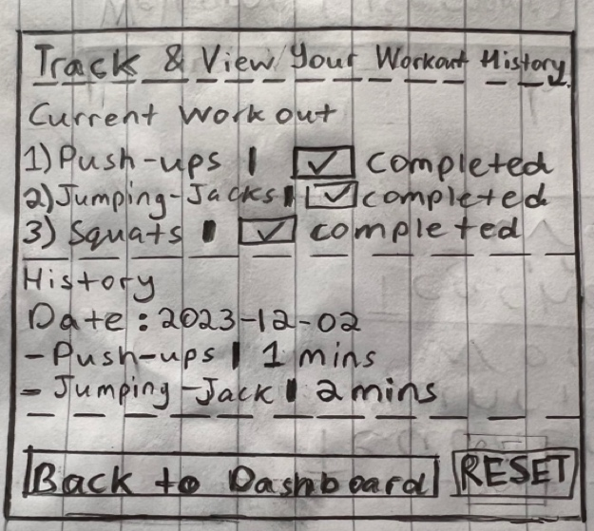

The user will be directed to this page when they press the “View History & Track” button on the home page. On this page, the label “Current Workout” will display the exercises completed by the user on the fourth page. When the user presses on the button “Finish Workout” on the fourth page, the box will be ticked. The History Label will just display all the workouts a user has added to his “Exercises” on the specific date. For your information, users will be directed to press the “RESET” button every day, which will delete the exercises from “Exercises” and reset the “History” and “Current Workout” to empty.